Assignment No. 1 (Solution File)
Name: Junaid Jabar
Student ID: Bc240404956
Question 1:
Context Level DFD
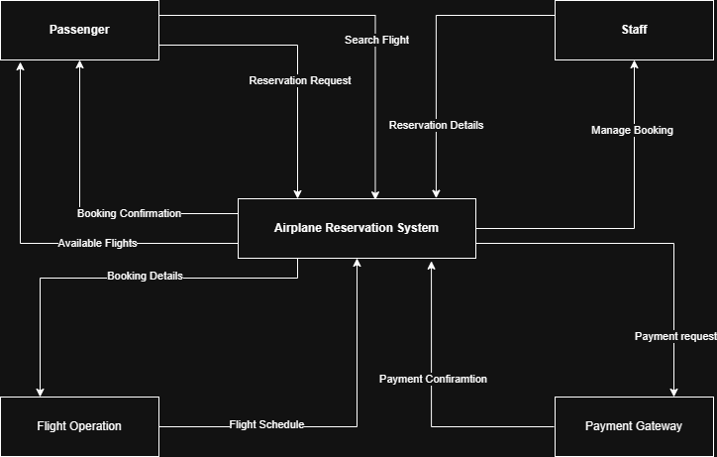

Question 2:
Level 1 DFD
